Project Design Phase
Proposed Solution
Date | 02 NOVEMBER 2025
Team ID | NM2025TMID02363
Project Name | Laptop Request Catalog Item
Maximum Mark | 2 Marks

Proposed Solution Template
S.N0 | Parameter | Description
1 | Problem Statement (Problem to be solved) | Employees face delays and confusion when requesting laptops due to a manual and static request process. There is no dynamic validation or guided form behavior, leading to incomplete data submission and approval bottlenecks.
2 | Idea / Solution Description | Create a Service Catalog Item in ServiceNow for laptop requests. Use UI Policies to dynamically display or hide fields and UI Actions to enable features like resetting the form. Add workflow automation to route requests for approval and fulfillment, ensuring clear tracking and faster processing.
3 | Novelty / Uniqueness | The solution integrates native ServiceNow features  (UI Policies, Client Scripts,  UI Actions, and Flow Designer) to create an intelligent, interactive catalog form — without external plugins or complex customization. It ensures a smart and error-free request system.
4 | Social Impact / Customer Satisfaction | Simplifies laptop request and approval processes, improving transparency, employee satisfaction, and IT service efficiency. Helps organizations maintain clear records and reduces administrative delays.
5 | Business Model (Revenue Model) | Not directly revenue-based, but improves IT operational efficiency, reduces repetitive support tasks, and saves employee time — resulting in higher productivity and cost-effectiveness for enterprises.
6 | Scalability of the Solution | The architecture can be scaled to include other hardware or asset requests (like desktops, accessories, or software). It can also support automated approval  hierarchies for large organizations.

Conclusion
The project “Laptop Request Catalog Item” addresses a common challenge in IT service management — slow, manual hardware request processes. By automating the workflow through a Service Catalog item with dynamic form behavior, it enhances accuracy, reduces processing time, and improves user satisfaction.
This innovative yet simple solution leverages native ServiceNow features like UI Policies, UI Actions, and Flow Designer, ensuring easy maintenance and high adaptability. It provides a strong foundation for automating similar request systems across enterprises, leading to smoother IT operations and better service delivery.
Solution Description
The Laptop Request Catalog Item enables employees to submit requests for laptops through an intuitive, guided interface. When users open the catalog form, dynamic UI Policies adjust visible fields based on their role or laptop type selection. UI Actions provide shortcuts like “Reset Form” or “Submit Request.”
After submission, the Workflow/Flow Designer automatically routes the request to the appropriate manager or IT approver. Status tracking ensures transparency at each step.
This plugin-free approach maintains clean data flow, faster approvals, and better accountability in IT resource management.
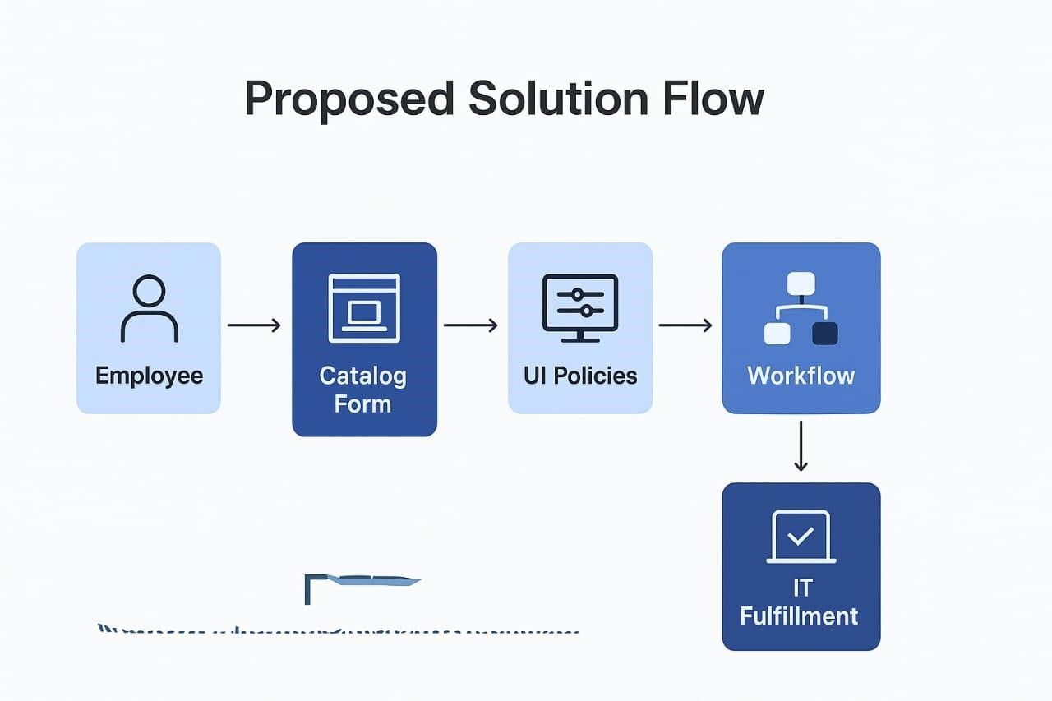

Reference: Infographic created using ServiceNow Developer Portal and IdeaHackers templates.

